1. History and Applications of C
C is a procedural general-purpose programming language that was originally created by Dennis Ritchie in 1972 in Bell Laboratories of AT&T Labs. It was originally intended as a system programming language to implement the UNIX system. C is universally applied in a variety of applications owing to being memory-efficient, being able to provide low-level control, and being portable.
1.1 Applications of C
C’s versatility and efficiency have made it a cornerstone in numerous fields of computing:
- Operating Systems
  - C is used to develop operating systems like Linux, UNIX and Windows.
  - It provides high speed and low-level hardware control.
- Embedded Systems
  - C is used in Arduino, IoT devices and automotive systems.
  - It can directly interact with hardware and uses less memory.
- Compilers and Interpreters
  - C is used to develop compilers and interpreters.
  - Examples: GCC and CPython.
- Databases
  - C is used in databases for fast data processing.
  - Examples: SQLite, MySQL and PostgreSQL.
- Networking
  - C is used in network programming and communication systems.
  - It supports efficient socket programming.
- Game Development
  - C is used for performance-based tasks like graphics, physics and game engines.
- Scientific Computing
  - C is used for mathematical calculations, simulations and scientific applications.
  - It is useful where high speed is required.
- Real-Time Systems
  - C is used in medical devices, aerospace and industrial automation.
  - It provides fast and predictable execution.

2. Structure of the C Program
The structure of a C program defines how its components are organized to make the code easier to read, understand, and maintain.
- A C program commonly contains preprocessor directives, declarations, the main() function, and user-defined functions.
- These components are organized according to the requirements of the program rather than a mandatory fixed order.
- A well-structured program makes development, debugging, and maintenance easier.

Sections of the C Program
There are 6 basic sections responsible for the proper execution of a program. Sections are mentioned below:
1. Documentation
The documentation section describes the purpose and other relevant details of the program using comments.
- It may include the program name, description, author, or creation date and time.
- Comments are ignored by the compiler and do not affect program execution.
- It provides an overview of the program and improves readability.
// description, name of the program, programmer name, date, time etc.
or
/*
description, name of the program, programmer name, date, time etc.
*/

2. Preprocessor Section
All the header files of the program will be declared in the preprocessor section of the program. Header files help us to access other's improved code into our code. A copy of these multiple files is inserted into our program before the process of compilation.
#include<stdio.h>
#include<math.h>

3. Definition
Preprocessors process source code before compilation. Preprocessor directives begin with #. The #define directive is used to define constants or macros, which are replaced with their corresponding values or code during preprocessing.
#define long long ll

4. Global Declaration
The global declaration section contains global variables, function declaration, and static variables. Variables and functions which are declared in this scope can be used anywhere in the program.
int num = 18;

5. Main() Function
Every C program must have a main() function, which serves as the entry point of the program. Declarations and executable statements are written inside its curly braces {}. The main() function typically returns an integer using int main(), where return 0 indicates successful program execution.
void main()
or
int main()

6. User-Defined Functions
User-defined functions are called in this section of the program. The control of the program is shifted to the called function whenever they are called from the main or outside the main() function. These are specified as per the requirements of the programmer.
int sum(int x, int y)
{
return x+y;
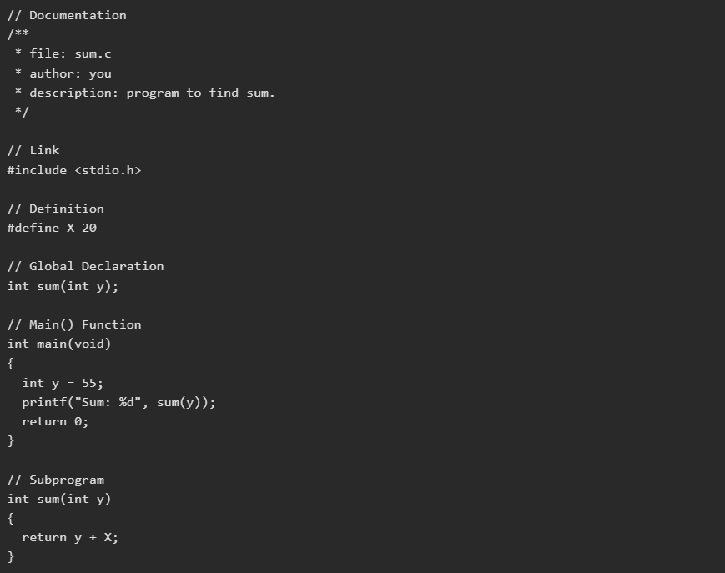
Output
Sum: 75

Explanation
This program demonstrates the basic structure of a C program by calculating the sum of a number and a predefined constant.
- #include <stdio.h> includes the standard input-output library for using printf().
- #define X 20 defines X as a constant with the value 20.
- int sum(int y); declares the user-defined sum() function before main().
- The main() function initializes y with 55 and calls sum(y) to calculate the result.
- The sum() function returns y + X, which gives 55 + 20 = 75.
- printf() displays the result as Sum: 75.
Steps Involved in Compilation and Execution of a C Program
The following steps are involved in compiling and executing a C program:
- Program Creation: Write the source code in a C source file.
- Compilation: Compile the source code to check for errors and generate executable code.
- Execution: Run the compiled program.
- Output: View the result produced by the program.

3. C Basic Syntax

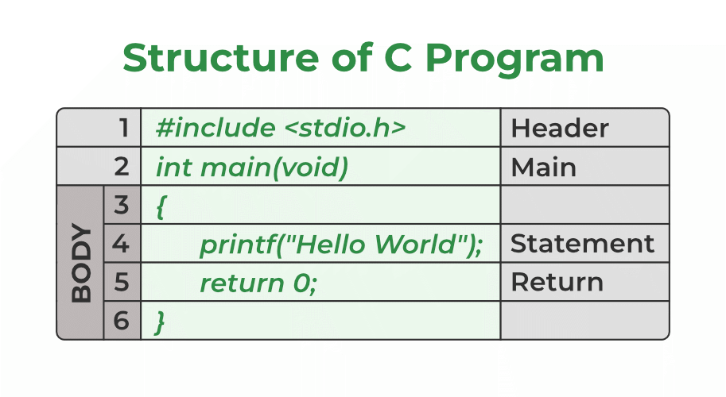

4. Data Types in C
Data types form the foundation of data representation in C. Every variable in C must be associated with a data type that defines the kind of value it can store and how the compiler handles it.
- Data types define memory allocation, value range, and valid operations on a variable.
- Understanding data types is essential for writing correct and efficient C programs.

*Format specifiers are the symbols that are used for printing and scanning values of given data types.

Classification of Data Types in C
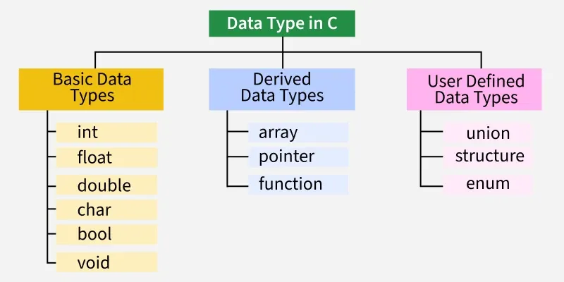

Primitive Data Types
Primitive data types are the basic built-in data types in C used to store simple values like integers, characters, and floating-point numbers.

Integer Data Type
- Stores whole numbers (positive, negative, or zero).
- We use int keyword to declare the integer variable:
- Size: typically 4 bytes, Range: -2,147,483,648 to 2,147,483,647.
- Format specifier: %d.

Character Data Type
- Stores a single character (like ‘A’, ‘b’, or ‘5’).
- Size: typically 1 byte, Range: -128 to 127 (signed by default).
- Format specifier: %c.

Float Data Type
- Stores decimal numbers (numbers with fractional part).
- Size: typically 4 bytes, Approximate range: 3.4e-38 to 3.4e+38.
- Format specifier: %f.

Double Data Type
- Stores decimal numbers with more precision than float.
- Size: typically 8 bytes, Approximate range: 1.7e-308 to 1.7e+308.
- Format specifier: %lf.

Void Data Type
- Represents no value or empty type.
- Used in functions that do not return any value.
- Can also be used for generic pointers (void *) in memory operations.

Data Type | Stores | Size | Range | Format Specifier
int | Whole numbers | 4 bytes | -2,147,483,648 to 2,147,483,647 | %d
char | Single character | 1 byte | -128 to 127 | %c
float | Decimal numbers | 4 bytes | 3.4 × 10⁻³⁸ to 3.4 × 10³⁸ | %f
double | Decimal numbers with more precision | 8 bytes | 1.7 × 10⁻³⁰⁸ to 1.7 × 10³⁰⁸ | %lf
void | No value | — | — | —

5. Constants in C
In C programming, const is a keyword used to declare a variable as constant, meaning its value cannot be changed after it is initialized. It is mainly used to protect variables from being accidentally modified, making the program safer and easier to understand. These constants can be of various types, such as integer, floating-point, string, or character constants.

Syntax
We define a constant in C using the const keyword. Also known as a const type qualifier, the const keyword is placed at the start of the variable declaration to declare that variable as a constant.
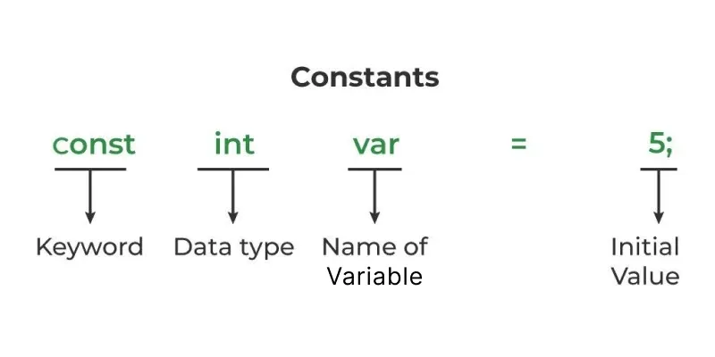

6. Variables in C
A variable in C is a named piece of memory which is used to store data and access it whenever required.
- It allows us to use the memory without having to memorize the exact memory address.
- To create a variable in C, we have to specify a name and the type of data it is going to store.
- C provides different data types that can store almost all kinds of data. For example, int, char, float, double, etc.
- Every variable must be declared before it is used. We can also declare multiple variables of same data type in a single statement by separating them using comma .

Rules for Naming Variables in C
We can assign any name to a C variable as long as it follows the following rules:
- A variable name must only contain letters, digits, and underscores.
- It must start with an alphabet or an underscore only. It cannot start with a digit.
- No white space is allowed within the variable name.
- A variable name must not be any reserved word or keyword.
- The name must be unique in the program.

C Variable Initialization
- Once the variable is declared, we can store useful values in it. The first value we store is called initial value and the process is called Initialization. It is done using assignment operator (=).
- It is important to initialize a variable because a C variable only contains garbage value when it is declared. We can also initialize a variable along with declaration.

Accessing Variables
The data stored inside a C variable can be easily accessed by using the variable's name.

Changing Stored Values
We can also update the value of a variable with a new value whenever needed by using the assignment operator =.
#include <stdio.h>

int main()
{

// initial value
int number = 10;
printf("Initial value: %d\n", number);

// updating value
number = 25;
printf("Updated value: %d\n", number);

// updating again using expression
number = number + 5;
printf("After adding 5: %d\n", number);

return 0;
}

How to use variables in C?
#include <stdio.h>
int main()
{

// Expression that uses values
int sum1 = 20 + 40;

// Defining variables
int a = 20, b = 40;

// Expression that uses variables
int sum2 = a + b + 10;

printf("%d\n%d", sum1, sum2);
return 0;
}

Memory Allocation of C Variables
When a variable is declared, the compiler is told that the variable with the given name and type exists in the program. But no memory is allocated to it yet. Memory is allocated when the variable is defined.
Most programming languages like C generally declare and define a variable in the single step. For example, in the above part where we create a variable, variable is declared and defined in a single statement.
The size of memory assigned for variables depends on the type of variable. We can check the size of the variables using size of operator.
#include <stdio.h>

int main() {
int num = 22;

// Finding size of num
printf("%d bytes", sizeof(num));
return 0;
}

Operators
An operator is a symbol that tells the compiler to perform specific mathematical or logical functions on operands. The data items on which the operators works are called as operands.
• The operators that act on only one operand (variable) are called unary operators.
• The operators that act on two operand (variables) are called as binary operators.
• The operators that act on three operand (variables) are called as ternary operators

7. Arithmetic Operators in C
Arithmetic operators in C are used to perform mathematical calculations on numeric values such as integers and floating-point numbers. They enable operations like addition, subtraction, multiplication, division, and modulus, making them essential for performing calculations, processing data, and solving computational problems in C programs.
- Support both integer and floating-point calculations.
- Classified into binary and unary arithmetic operators.

Arithmetic operators can be classified into two types based on the number of operands
Binary Arithmetic Operators
Binary arithmetic operators work on two operands and perform mathematical operations such as addition, subtraction, multiplication, division, and modulus.
- Perform basic mathematical calculations.
- Return a numeric result.
- Work with both variables and constants.

Note: All arithmetic operators can be used with float and int types except the modulo operator that can only be used with integers.

The binary arithmetic operators work on two operands. C provides 5 such operators for performing arithmetic functions which are as follows:
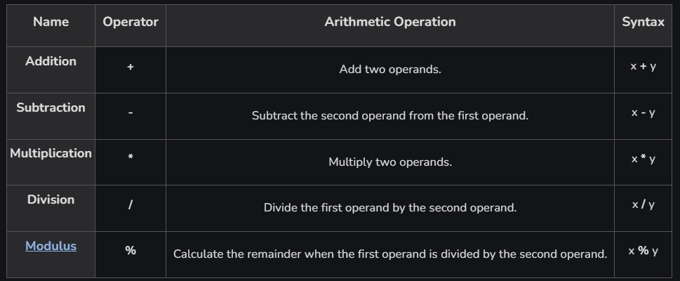

Unary Arithmetic Operators
Unary arithmetic operators work on a single operand and are mainly used to increase, decrease, or change the sign of a value.
- Include increment (++) and decrement (--) operators.
- Support unary plus (+) and unary minus (-).
- Useful for counters and loop control.
The unary arithmetic operators work with a single operand. In C, we have four such operators which are as follows:
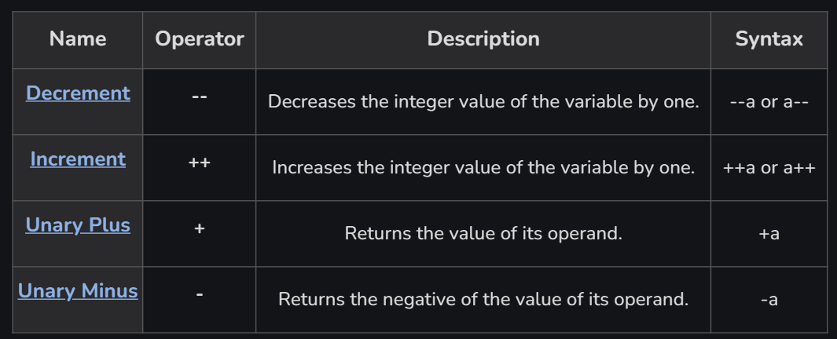

#include <stdio.h>

int main()
{
int a = 10, res;

// post-incrementing a res is assigned 10, a is not updated yet
res = a++;

printf("a is %d, res is %d\n", a, res);

// post-decrementing res is assigned 11, a is not updated yet
res = a--;

printf("a is %d, res is %d\n", a, res);

res = ++a;

// a and res have same values = 11
printf("a is %d, res is %d\n", a, res);

res = --a;

// a and res have same values = 10
printf("a is %d, res is %d\n", a, res);

printf("+a is %d\n", +a);
printf("-a is %d", -a);

return 0;
}

Output
a is 11, res is 10
a is 10, res is 11
a is 11, res is 11
a is 10, res is 10
+a is 10
-a is -10

Explanation: In the given example, postfix operators (a++, a--) first assign the current value and then update the variable. Prefix operators (++a, --a) update the variable first and then use the updated value. Unary plus returns the value unchanged, while unary minus returns its negative value.

8. Relational Operators in C
Relational operators in C are used to compare two values or expressions and determine the relationship between them. They are commonly used in decision-making statements such as if, if-else, while, and for loops to control the flow of a program based on conditions.
- Used to compare two operands or expressions.
- Always return 1 (true) or 0 (false).
- Commonly used in conditional and looping statements.
Types of C Relational Operators
There are a total of 6 relational operators in C language. There are:
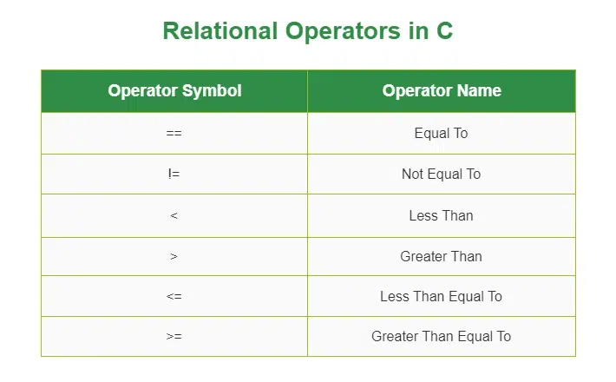

1. Equal to operator (==)
The C equal to operator (==) is a relational operator that is used to check whether the two given operands are equal or not.
- Equal to operator is a binary operator hence it requires two operands to perform the comparison.
- If the two values are equal, it returns true. Otherwise, it returns false.
Syntax
operand1 == operand2
For example, 5==5 will return true.
2. Not equal to operator (!=)
The C not equal (==) to operator is another relational operator used for checking whether the two given operands are equal or not.
- It is also a binary operator, requiring two operands to perform the comparison.
- It is the exact boolean complement of the '==' operator which returns true if the two values are not equal, false otherwise.
Syntax
operand1 != operand2
For example, 5!=5 will return false.
3. Greater than operator (>)
The greater than operator is a relational operator in C that checks whether the first operand is greater than the second operand or not.
- If the operand first is greater than the operand2, it returns true. Otherwise, it returns false.
- This operator is used to make decisions or create conditions based on the relative magnitude of two values.
Syntax
operand1 > operand2
For example, 6>5 will return true.

4. Less than operator (<)
The less than operator is a relational operator in C that checks whether the first operand is lesser than the second operand.
- If the operand first is less than the operand2, it returns true. Otherwise, it returns false.
- This operator is also used to make decisions or create conditions based on the relative magnitude of two values.
Syntax
operand1 < operand2
For example, 6<5 will return false.
Note: The greater than and less than operator are not equal to the complement of each other.

5. Greater than or equal to operator (>=)
The greater than or equal to the operator is a relational operator in C that checks whether the first operand is greater than or equal to the second operand.
- It is a binary operator.
- If the first operand is greater than or equal to the second operand, it returns true. Otherwise, it returns false.
Syntax
operand1 >= operand2
For example, 5>=5 will return true.

6. Less than or equal to the the operator (<=)
The less than or equal to the operator is a relational operator in C that checks whether the first operand is less than or equal to the second operand.
- It is a binary operator.
- If the first operand is less than or equal to the second operand, it returns true. Otherwise, it returns false.
Syntax
operand1 <= operand2
For example, 5<=5 will also return true.

Example of Relational Operator in C:
#include <stdio.h>

int main()
{
int a = 10, b = 4;

// greater than example
if (a > b)
printf("a is greater than b\n");
else
printf("a is less than or equal to b\n");

// greater than equal to
if (a >= b)
printf("a is greater than or equal to b\n");
else
printf("a is lesser than b\n");

// less than example
if (a < b)
printf("a is less than b\n");
else
printf("a is greater than or equal to b\n");

// lesser than equal to
if (a <= b)
printf("a is lesser than or equal to b\n");
else
printf("a is greater than b\n");

// equal to
if (a == b)
printf("a is equal to b\n");
else
printf("a and b are not equal\n");

// not equal to
if (a != b)
printf("a is not equal to b\n");
else
printf("a is equal b\n");

return 0;
}

Output:
a is greater than b
a is greater than or equal to b
a is greater than or equal to b
a is greater than b
a and b are not equal
a is not equal to b

Explanation: In this program, different relational operators are used to compare the values of a (10) and b (4). Since 10 is greater than 4, the conditions a > b, a >= b, and a != b evaluate to true, while a < b, a <= b, and a == b evaluate to false. Based on these results, the corresponding messages are printed to the console.

Advantages of Relational Operators in C
- Enable Decision Making: Help programs make decisions using conditions in if, if-else, and switch statements.
- Support Loop Control: Used in loops such as while, for, and do-while to control execution.
- Easy Value Comparison: Allow comparison of variables, constants, and expressions efficiently.
- Return Simple Results: Produce either 1 (true) or 0 (false), making conditions easy to evaluate.
- Improve Program Logic: Help implement validation, searching, sorting, and other logical operations.
- Increase Code Readability: Make conditional expressions concise and easy to understand.
- Widely Used in Algorithms: Essential for implementing comparison-based algorithms and data processing tasks.

9. C Logical Operators
Logical operators in C are used to combine or reverse conditions. They help a program make decisions based on whether conditions are true or false.
- Logical operators return 1 when the result is true and 0 when the result is false.
- C provides three logical operators: AND (&&), OR (||), and NOT (!).

Types of Logical Operators
C provides three logical operators:

1. Logical AND Operator ( && )
The logical AND operator (&&) returns 1 when both conditions are true. If either condition is false, it returns 0.
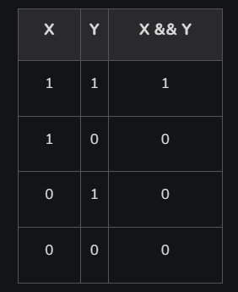

#include <stdio.h>
int main()
{
int a = 10, b = 20;

if (a > 0 && b > 0)
{
printf("Both values are greater than 0\n");
}
else
{
printf("One or both values are less than or equal to 0\n");
}
return 0;
}

Output
Both values are greater than 0

Here, both a > 0 and b > 0 are true, so the AND condition is true.

2. Logical OR Operator ( || )
The logical OR operator (||) returns 1 when at least one condition is true. It returns 0 only when both conditions are false.

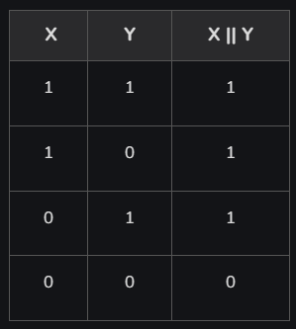
#include <stdio.h>

int main()
{
int a = -1, b = 20;

if (a > 0 || b > 0)
{
printf("Any one of the given value is "
"greater than 0\n");
}
else
{
printf("Both values are less than or equal to 0\n");
}
return 0;
}

Output
Any one of the given value is greater than 0

Here, a > 0 is false, but b > 0 is true. Therefore, the OR condition is true.

3. Logical NOT Operator ( ! )
The logical NOT operator (!) reverses the result of a condition. It changes true to false and false to true.
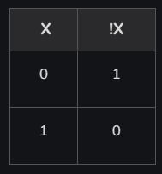

#include <stdio.h>

int main() {
int a = 10, b = 20;

if (!(a > 0 && b > 0)) {
printf("Both values are not greater than 0\n");
}
else {
printf("Both values are greater than 0\n");
}

return 0;
}

Output
Both values are greater than 0

Here, a > 0 && b > 0 is true. The ! operator reverses it to false, so the else block is executed.

10. Bitwise Operators in C
Bitwise operators in C operate directly on the binary representation of integer values, performing operations bit by bit instead of on whole numbers. These operators are widely used in low-level programming, optimization, and embedded systems.
- Work with integral data types like char, short, int, and long.
- Used in system programming, embedded systems, and bit masking.
- Help perform fast operations such as shifting, toggling, and checking bits.
Types of Bitwise Operators in C
Bitwise operators in C perform operations directly on the individual bits of integer data, enabling efficient low-level data manipulation and optimization.
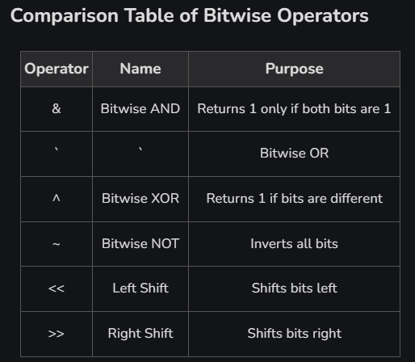

11. Conditional or Ternary Operator (?:) in C
The conditional operator (?:) is a shorthand way of writing simple if-else statement. It evaluates a condition and returns one of two expressions based on whether the condition is true or false.
- Reduces code length by replacing simple if-else statements with a single expression.
- Improves code readability when performing straightforward conditional assignments.
#include <stdio.h>
​
int main() {
int a = 10, b = 20;
​
int max = (a > b) ? a : b;
​
printf("Maximum = %d", max);
​
return 0;

}
Output
Maximum = 20

Syntax
The conditional operator can be in the form
variable = Expression1 ? Expression2 : Expression3;

Or the syntax can also be in this form
variable = (condition) ? Expression2 : Expression3;

Or syntax can also be in this form
(condition) ? (variable = Expression2) : (variable = Expression3);

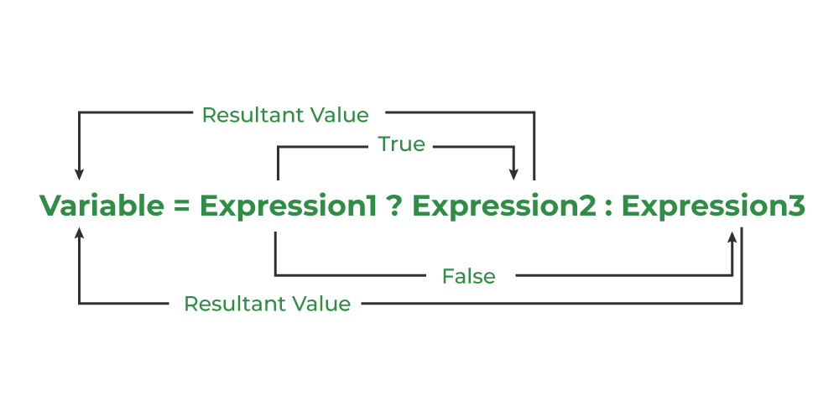

It can be visualized into an if-else statement as:
if(Expression1){
variable = Expression2;
}else{
variable = Expression3;
}

Since the Conditional Operator '?:' takes three operands to work, hence they are also called ternary operators.
Note: The conditional (?:) operator has one of the lowest operator precedences in C. Use parentheses when combining it with other operators to avoid unexpected results.
Working
The working of the conditional operator in C is as follows:
- Step 1: Expression1 is the condition to be evaluated.
- Step 2A: If the condition (Expression1) is True then Expression2 will be executed.
- Step 2B: If the condition (Expression1) is false then Expression3 will be executed.
- Step 3: Results will be returned.
Flowchart of Conditional/Ternary Operator in C
To understand the working better, we can analyze the flowchart of the conditional operator given below.
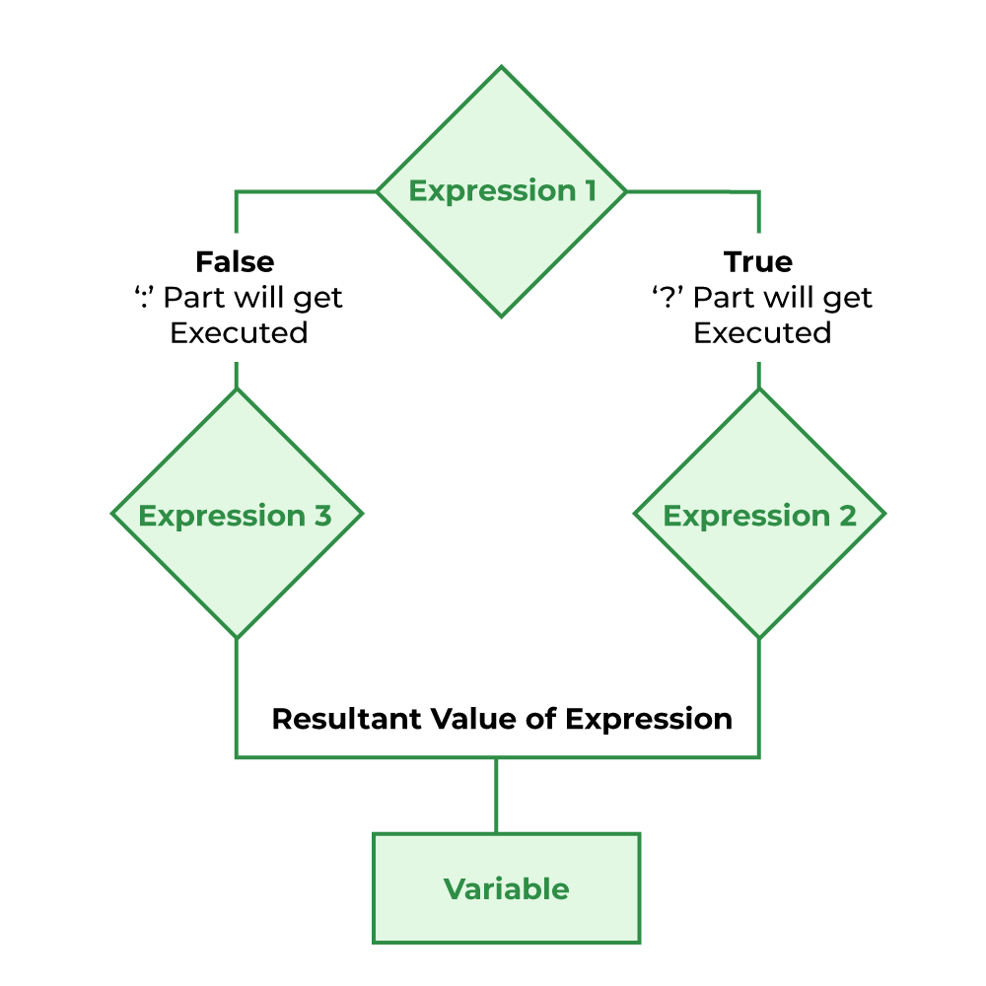

Example : C Program to check whether a year is a leap year using ternary operator
#include <stdio.h>

int main()
{
int yr = 1900;

(yr%4==0) ? (yr%100!=0? printf("The year %d is a leap year",yr)
: (yr%400==0 ? printf("The year %d is a leap year",yr)
: printf("The year %d is not a leap year",yr)))
: printf("The year %d is not a leap year",yr);
return 0;
}

//This code is contributed by Susobhan AKhuli

Output
The year 1900 is not a leap year

Advantages
The conditional (?:) operator provides a concise and efficient way to write simple conditional expressions.
- Reduces Code Length: Replaces simple if-else statements with a single, compact expression.
- Improves Readability: Makes straightforward conditional assignments easier to read and understand.
- Supports Expression-Based Programming: Can be used directly in assignments, function arguments, and return statements.
Limitations
Although the conditional operator simplifies simple conditions, it is not suitable for every programming scenario.
- Not Ideal for Complex Logic: Nested or complex conditional expressions can make the code difficult to read and maintain.
- Limited to Single Expressions: It cannot replace if-else when multiple statements need to be executed in each branch.
- May Reduce Readability: Excessive use of nested ternary operators can make code confusing and error-prone

12. Expression
Expression: An expression is a combination of operators, constants and variables. An expression may consist of one or more operands, and zero or more operators to produce a value.
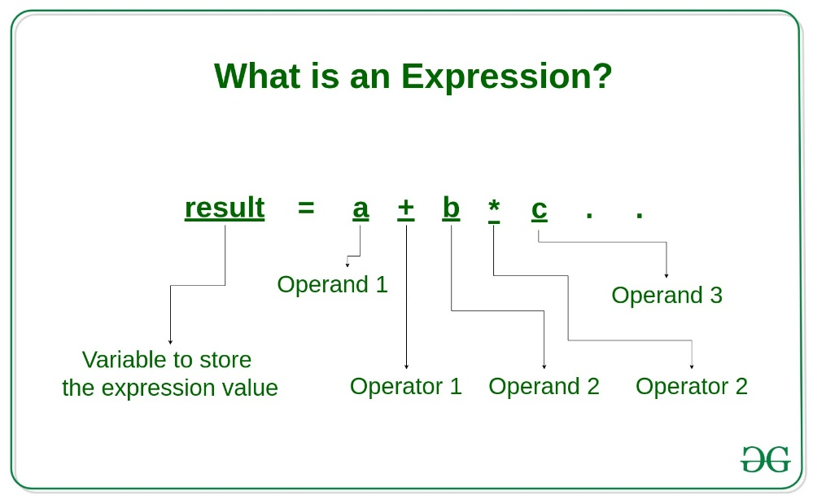

14. if , if..else
Conditional statements are used to execute different blocks of code based on whether a specified condition is true or false.
- They evaluate one or more conditions before making a decision.
- They help control the program flow by executing code only when required.
C has the following conditional statements:
- Use if to specify a block of code to be executed, if a specified condition is true
- Use else to specify a block of code to be executed, if the same condition is false
- Use else if to specify a new condition to test, if the first condition is false
- Use switch to specify many alternative blocks of code to be executed

The if Statement:
Use the if statement to specify a block of code to be executed if a condition is true.
Syntax
if (condition) {
// block of code to be executed if the condition is true
}

Note that if is written in lowercase letters. Uppercase letters (If or IF) will generate an error.

We can also test variables:
Example
int x = 20;
int y = 18;
if (x > y) {
printf("x is greater than y");
}

Example explained
In the example above we use two variables, x and y, to test whether x is greater than y (using the > operator). As x is 20 and y is 18, the condition is true, so the program prints "x is greater than y".

The else Statement
Use the else statement to specify a block of code to be executed if the condition is false.
Syntax
if (condition) {
// block of code to be executed if the condition is true
} else {
// block of code to be executed if the condition is false
}

In the example below, the program checks the value of time. If it is less than 18, it prints "Good day". Otherwise, it prints "Good evening":
Example
int time = 20;
if (time < 18) {
printf("Good day.");
} else {
printf("Good evening.");
}
// Outputs "Good evening."

Example explained
In the example above, time (20) is greater than 18, so the condition is false. Because of this, we move on to the else condition and print to the screen "Good evening". If time was less than 18, the program would print "Good day".

The else if Statement
Use the else if statement to specify a new condition to test if the first condition is false.
You can use else if to check multiple conditions, one after another.
Syntax
if (condition1) {
// block of code to be executed if condition1 is true
} else if (condition2) {
// block of code to be executed if condition1 is false and condition2 is true
} else {
// block of code to be executed if both conditions are false
}

The conditions are checked from top to bottom. As soon as one condition is true, its block of code runs, and the rest are skipped.

In the example below, we decide which message to print based on the value of time:
Example
int time = 16;
if (time < 12) {
printf("Good morning.");
} else if (time < 18) {
printf("Good day.");
} else {
printf("Good evening.");
}
// Outputs "Good day."

Example explained
The value of time is 16. The first condition (time < 12) is false, but the second condition (time < 18) is true. Because of this, the code inside the else if block runs, and "Good day." is printed.
If the value of time was 22, none of the conditions would be true, and the program would print "Good evening." instead.

Nested If
You can also place an if statement inside another if. This is called a nested if statement.
A nested if lets you check for a condition only if another condition is already true.
Syntax
if (condition1) {
// code to run if condition1 is true
if (condition2) {
// code to run if both condition1 and condition2 are true
}
}

In this example, we first check if x is greater than 10. If it is, we then check if y is greater than 20:

int x = 15;
int y = 25;

if (x > 10) {
printf("x is greater than 10\n");

// Nested if
if (y > 20) {
printf("y is also greater than 20\n");
}
}

Result:
x is greater than 10
y is also greater than 20

Real-Life Example
Nested if statements are useful when you need to test multiple conditions that depend on each other. For example, checking if a person is old enough to vote, and if they are a citizen:

int age = 20;
bool isCitizen = true;

if (age >= 18) {
printf("Old enough to vote.\n");

if (isCitizen) {
printf("And you are a citizen, so you can vote!\n");
} else {
printf("But you must be a citizen to vote.\n");
}
} else {
printf("Not old enough to vote.\n");
}

Result:
Old enough to vote.
And you are a citizen, so you can vote!

15. Loops
A loop is a control structure used to repeat a set of statements again and again until a given condition becomes false.
Types of loops in C:
- for loop
- while loop
- do-while loop
for loops
In C programming, the 'for' loop is a control flow statement that is used to repeatedly execute a block of code as many times as instructed. It uses a variable (loop variable) whose value is used to decide the number of repetitions. It is commonly used to iterate over a sequence such as an array or list.
#include <stdio.h>
​
int main() {
​
// for loop to print "Hi" 5 times
for (int i = 1; i <= 5; i++) {
printf("Hi\n");
}
​
return 0;
}
Output
Hi
Hi
Hi
Hi
Hi
Explanation: In this example, the loop prints the text "Hi" 5 times. The loop variable i is initialized to 1. The condition i <= 5 is checked before each iteration. After each iteration, i is incremented by 1. So this loop was executed 5 times.
C for Loop Syntax
for (initialization; condition; updation) {
// Body of the loop
}
where,
- Initialization: This step is executed first, and it is typically used to initialize a loop control variable.
- Condition: This conditional expression is evaluated before each iteration. and if the condition is true, the loop body executes. if it's false, the loop terminates.
- Updation: This step is used to update the loop control variable and is executed after each iteration.
- body: The body of the loop are the set of statements that are executed when the condition is true.
Note: As we can see, unlike the while loop and do…while loop, the for loop contains the initialization, condition, and updating statements for loop as part of its syntax.
Working of For Loop
The working of for loop is mentioned below:
- Step 1: Initialization is the basic step of for loop this step occurs only once during the start of the loop. During Initialization, variables are declared, or already existing variables are assigned some value.
- Step 2: During the Second Step condition statements are checked and only if the condition is the satisfied loop we can further process otherwise loop is broken.
- Step 3: All the statements inside the loop are executed.
- Step 4: Updating the values of variables has been done as defined in the loop.
Continue to Step 2 till the loop breaks.

Flowchart of for Loop
The following flow chart defines the logic behind the working of for loop.
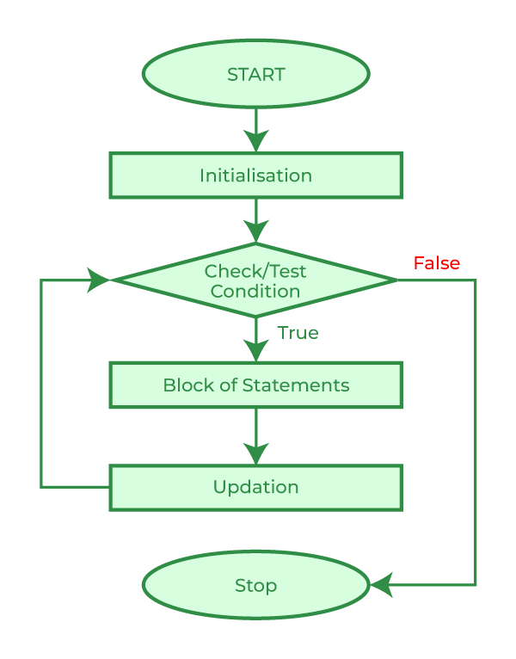

While Loop
The while loop repeats a block of code as long as a specified condition is true:
Syntax
while (condition) {
// code block to be executed
}

In the example below, the code in the loop will run, over and over again, as long as a variable (i) is less than 5:
Example
int i = 0;
while (i < 5) {
printf("%d\n", i);
i++;
}

Note: Do not forget to increase the variable used in the condition (i++), otherwise the loop will never end!
Do you wonder why we use the letter i as a variable name? It's a counter variable and a common choice in simple loops because it's short, traditional, and stands for 'index' or 'iterator'.

Countdown Example
You can also use a while loop to count down. This example counts from 3 to 1, and then prints "Happy New Year!!" at the end:
Example
int countdown = 3;
while (countdown > 0) {
printf("%d\n", countdown);
countdown--;
}
printf("Happy New Year!!\n");

While Loop With False Condition
In the previous examples, the condition was true at the start, so the loop ran one or more times. But if the condition is false at the beginning, the code inside the loop will never run:
Example
int i = 10;

while (i < 5) {
printf("This will never be printed\n");
i++;
}

Note: A while loop may never run if the condition is false from the start. In the next chapter, you will learn about the do while loop, which always runs the code at least once before checking the condition.

Do-While Loop
The do/while loop is a variant of the while loop. This loop will execute the code block once, before checking if the condition is true, then it will repeat the loop as long as the condition is true.
Syntax
do {
// code block to be executed
}
while (condition);
The example below uses a do/while loop. The loop will always be executed at least once, even if the condition is false, because the code block is executed before the condition is tested:
Example
int i = 0;
do {
printf("%d\n", i);
i++;
}
while (i < 5);

Do not forget to increase the variable used in the condition, otherwise the loop will never end!

Condition is False from the Start
In the example above, the condition i < 5 was true at the beginning, so the loop executed multiple times. But what if the condition is false right from the start?
In the example below, the variable i starts at 10, so the condition i < 5 is false immediately - yet the do/while loop still runs once:
Example
Even if the condition is false from the start, the code block will still execute one time:
int i = 10;
do {
printf("i is %d\n", i);
i++;
} while (i < 5);

Summary
The do/while loop always runs at least once, even if the condition is already false. This is different from a regular while loop, which would skip the loop entirely if the condition is false at the start.
This behavior makes do/while useful when you want to ensure something happens at least once, like showing a message or asking for user input.
Practical Example: User Input
This example keeps asking the user to enter a positive number. The loop stops when the user enters 0 or a negative number:
Example
int number;
do {
printf("Enter a positive number: ");
scanf("%d", &number);
} while (number > 0);

